# DeepSee System Monitor Dashboards

This is a simple set od DeepSee dashboards that complement %SYS.Monitor.* classes to allow users visual overview of system status.

In order to install you need

1. Create a new database, ( I used SYSMON as its name)
2. Create new namespace (again, I used SYSMON as its name)
   1. Use CACHESYS as default databases for this new namespace
   2. Map kutac.* package to your new (SYSMON) database
3. Import project file - ISC System Monitor Dashboard.xml into your namespace
4. Open cterm in %SYS namespace, run ^%SYSMONMGR utility
   1. Configure startup namespaces, add your namespace (SYSMON), %SYS and perhaps other if you wish to extend the project to capture more data
   2. Select Manage Application Monitor -> Manage Monitor Classes -> Activate/Deactivate Monitor classes

Something like this is what you want:

|  |  |
| --- | --- |
| Class Active | ----- ------ |
| %Monitor.System.HistoryPerf Y | %Monitor.System.HistorySys Y |
| %Monitor.System.HistoryUser N | %Monitor.System.AuditCount N |
| %Monitor.System.AuditEvents N | %Monitor.System.Clients N |
| %Monitor.System.Diskspace Y | %Monitor.System.Freespace Y |
| %Monitor.System.Globals N | %Monitor.System.Journals N |
| %Monitor.System.License Y | %Monitor.System.LockTable Y |
| %Monitor.System.Processes Y | %Monitor.System.Routines Y |
| %Monitor.System.Servers N | %Monitor.System.SystemMetrics N |
| %Monitor.System.CSPGateway N |  |

1. Go to Management Portal, select (SYSMON) namespace and User Portal, run dashboards nad see what they show.
   1. You can rebuild cubes when needed by selecting State Info and Actions dashboard, and clicking Synchronize Data, followed by refresh button next to if after a little while.

Couple dashboards for illustration:

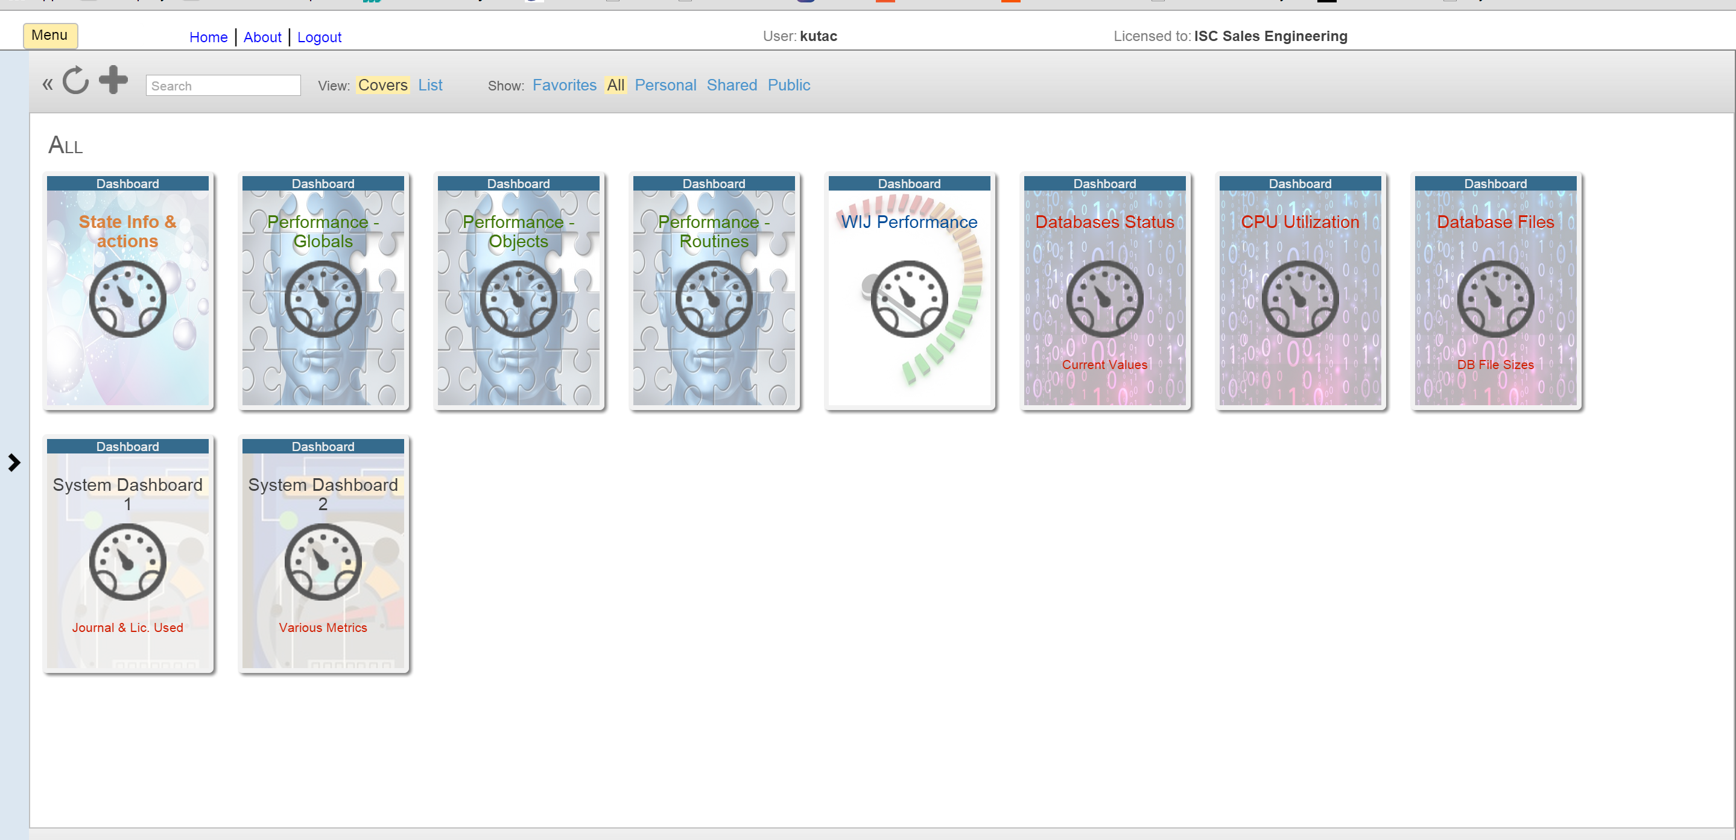

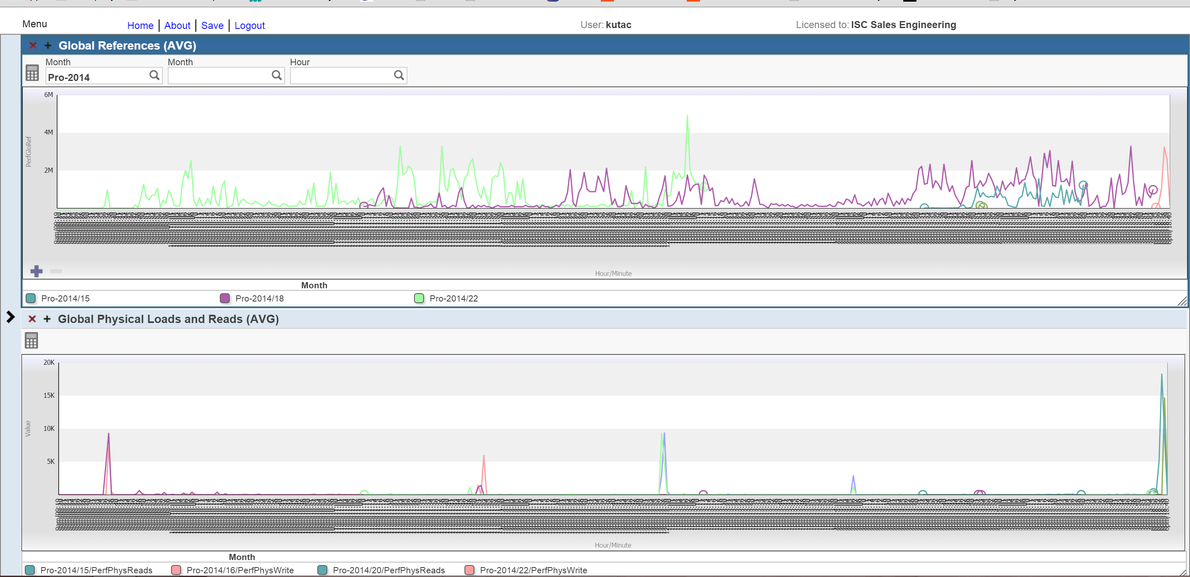

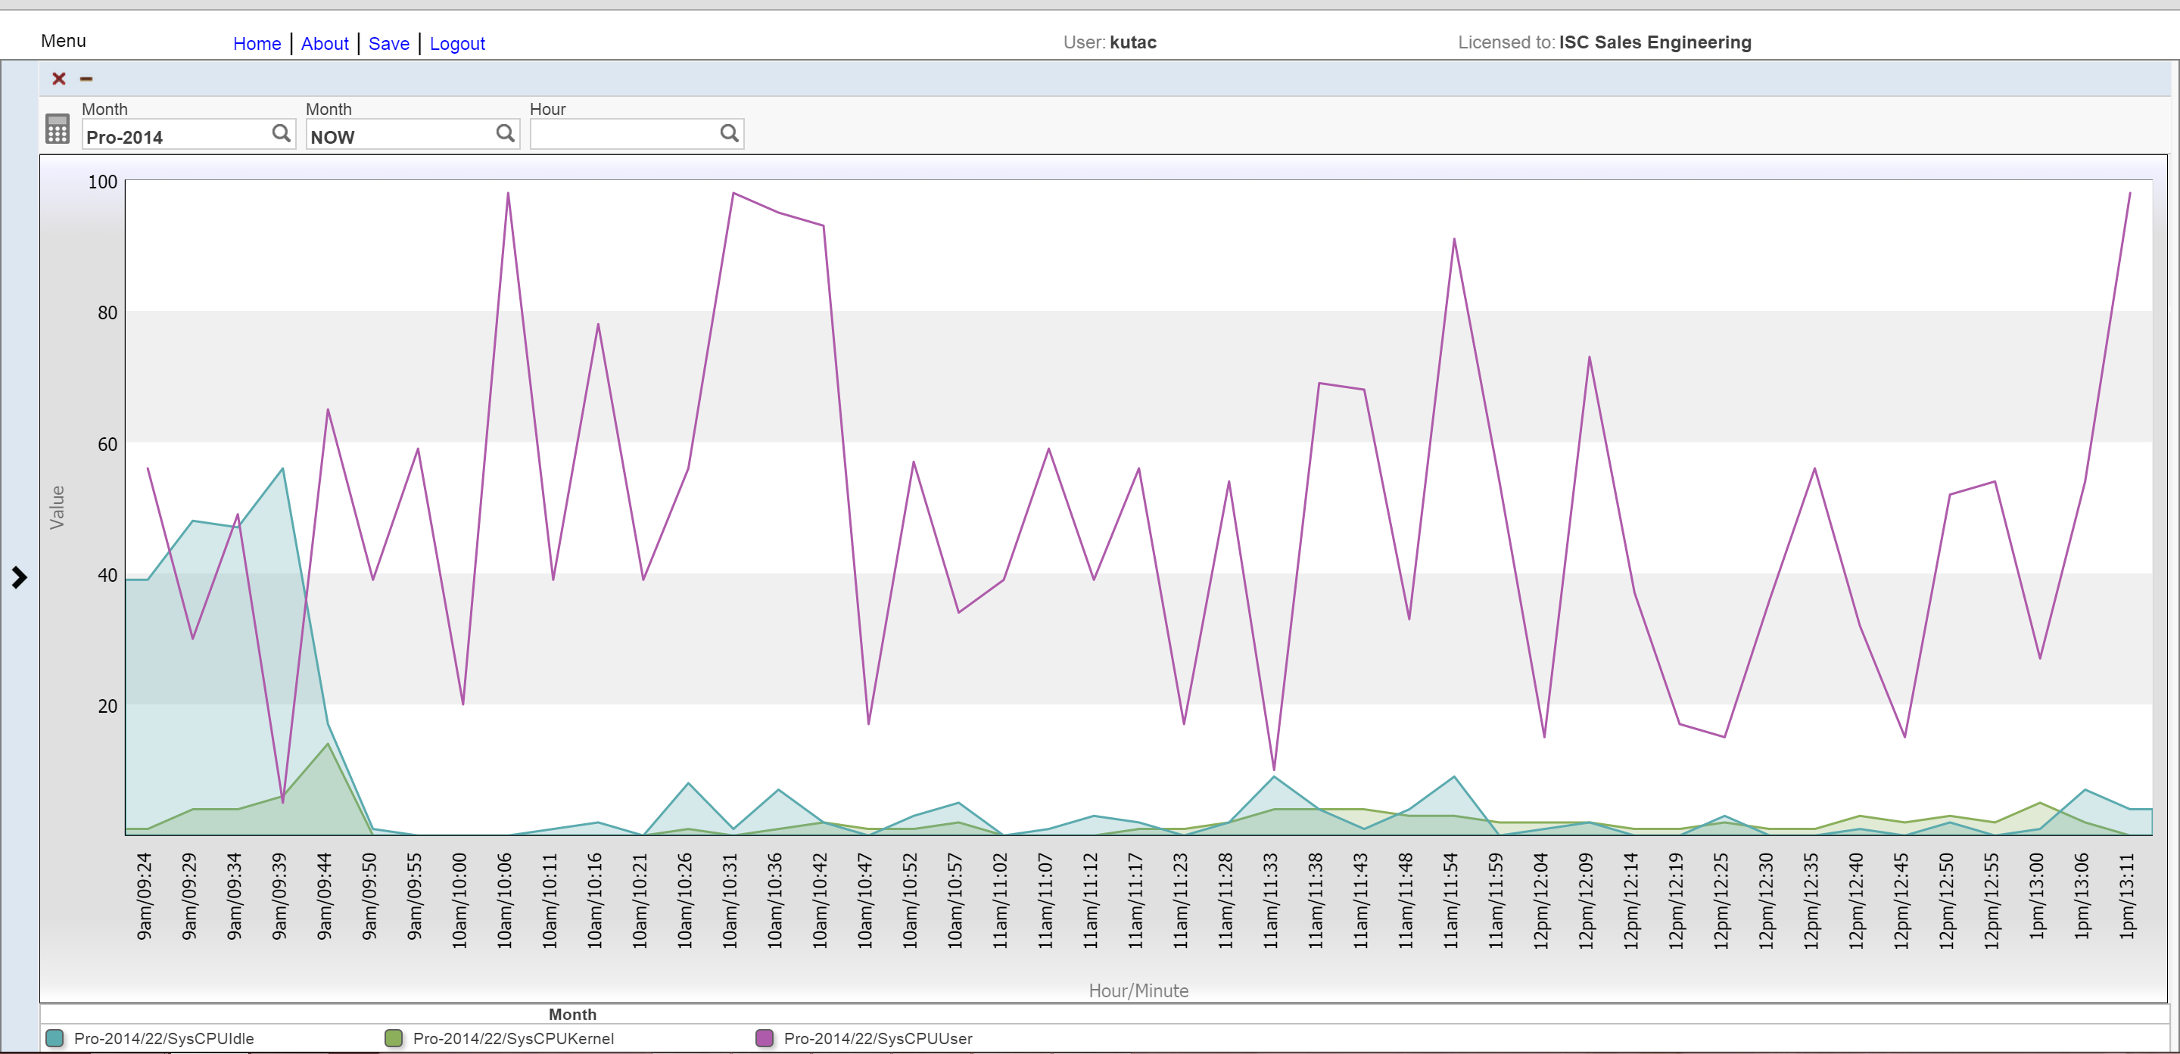

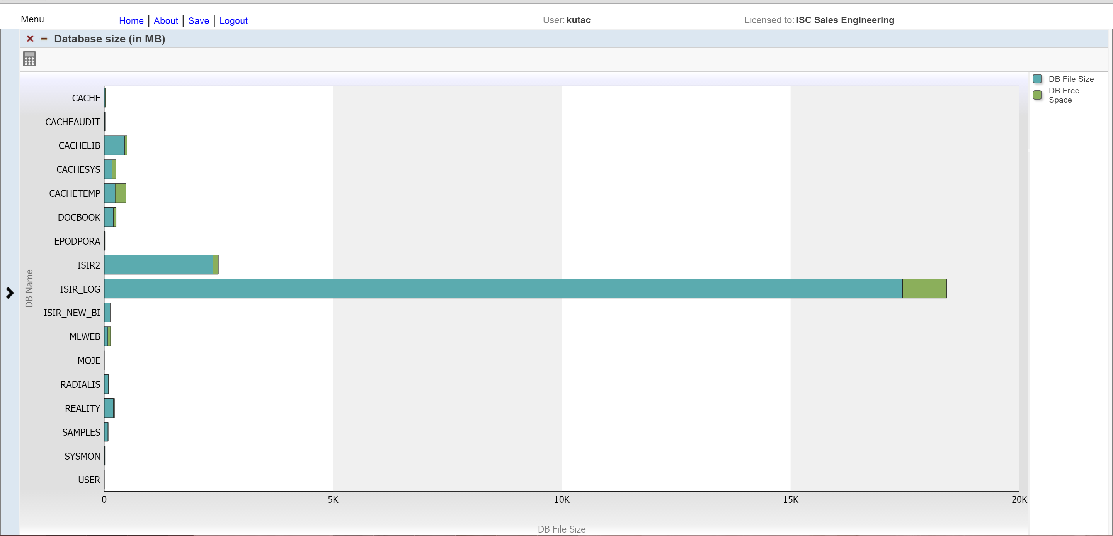

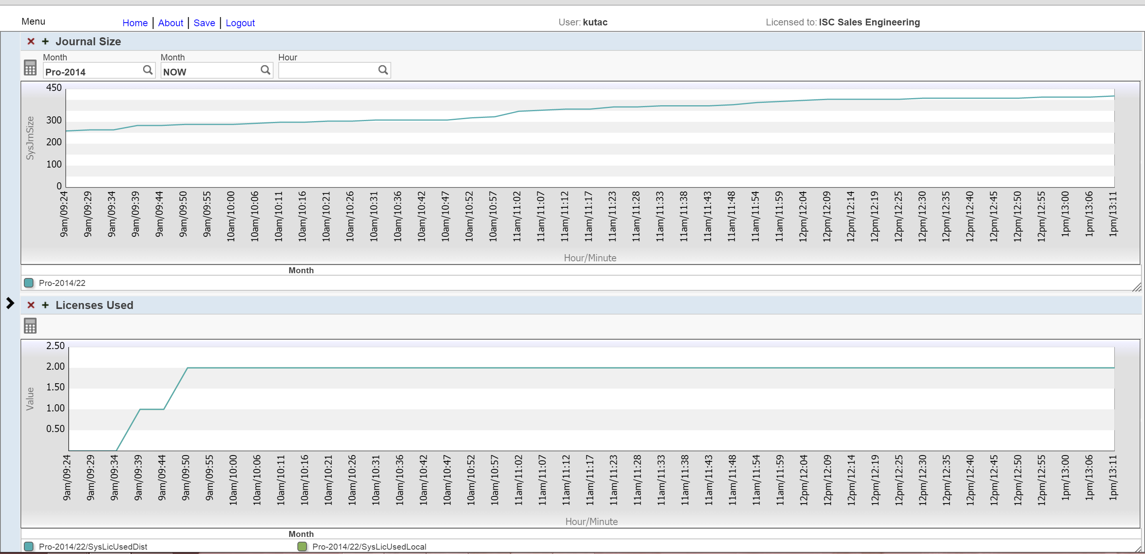

PS: I’m not expert on %SYS.Monitor so perhaps my list of classes is not correct. Also, there are some more tables in SYS_Monitor* schema that according to documentation should have data populated, but this is not happening on my system.

This is very simple set of measures, there is plenty of room for enhancements and in fact I wonder why something like these dashboards is not part of standard release of all our technology products, since we have all data necessary collected by several tools.